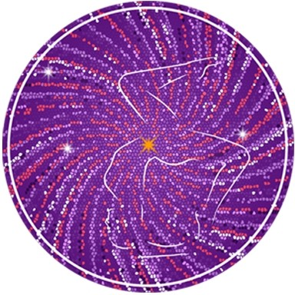

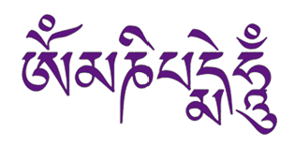
May the jewel

in the lotus

shine forth this light

of love

and compassion

to unite

all existences

as one
CLARITY YOGA SHALA

65 Hatfield Road

St Albans

AL1 4JE

ignite@clarity.yoga
www.clarity.yoga
+44 (0) 796 8823166

Clarity Yoga
Shala

YOGA TEACHER TRAINING
Surya Namaskara; Salutation to the Sun

Other Terms: Counting System; Asana Names; Dristi; Psychic Centres

Samasthitih equal standing
Nasagrai tip of nose
Anahata Unstriken/unsoiled/clean; behind the heart; thymus

1-Ekam: Puraka
Urdhva Hastasana Raised Hands Pose, Urdhva – Upward Hasta-hand
Agusta Ma Dyai Thumbs
Vishuddhi Pure/ Purification/harmony;thorax (neck, jaw, clavical, teeth; thyroid
Anahata

2-Dve: Recaka
Uttanasana A ut = intense tan = to stretch or extend
Nasagrai
Svadhisthana dwelling place of self; lower abdomen; testies & ovaries

3-Trini: Puraka
Uttanasana B
Bromadhya 3rd eye
Ajna Chakra wisdom/command centre/authority/connect to devine; piturity gland

4-Chatvari: Recaka
Chataranga Dandasana chatur = four; anga = limb;
danda = staff (refers to the spine, the central "staff" or support of the body)
Nasagrai
Manipura City of gems; solar plexus; pancreas

5-Pancha: Puraka
Urdhva Mukha Svanasana urdhva = upward; mukha = face; svana = dog
Bromadhya
Ajna Chakra
Svadhisthana

6-Shat: Recaka
Adho Mukha Svanasana adho = downward; mukha = face; svana = dog
Nabi Chakra navel
Manipura
Vishuddhi

7- Sapta: Puraka
Uttanasana B

8- Astau : Recaka
Uttanasana A

9-Nava: Puraka
Urdhva Hastasana

Samasthitih: Recaka
Ref: Surya Namaskara – Bihar School Yoga; Suryanamaskara Sri K Pattabhi Jois; Yoga Mala Sri K Pattabhi Jois; Michael Gannon

