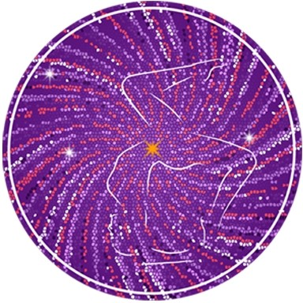

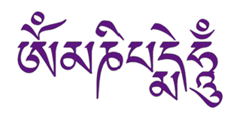
May the jewel

in the lotus

shine forth this light

of love

and compassion

to unite

all existences

as one
CLARITY YOGA SHALA

65 Hatfield Road

St Albans

AL1 4JE

ignite@clarity.yoga
www.clarity.yoga
+44 (0) 796 8823166

Clarity Yoga
Shala

YOGA TEACHER TRAINING
Pre Study Material : Asana Names

SEATED POSTURES PART 1

Dandhasana
Danda-staff

Paschimattanasana
Westward Facing

Purvattanasana
Eastward Facing

Ardha Baddha Padma Paschimattanasana
Ardha Half
Baddha Bound
Padma Foot
Paschimatta Westward
Asana Posture

Triang Mukhaekapada Paschimattanasana
Tri 3
Anga Limbs
Mukha Facing
Eka One
Pada Foot
Paschimattansana Westward Facing Asana

Janu Sirsasana
Janu Knee
Sirsa Head

Marichyasana
The Great Sage

Navasana
Boat

Ref: Michael Gannon of Ashtanga Americas; Astanga Yoga by Lino Miele

