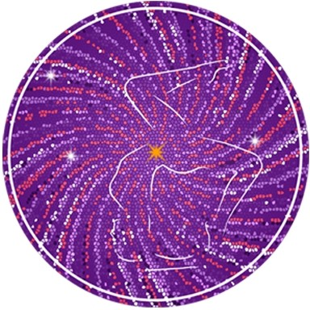

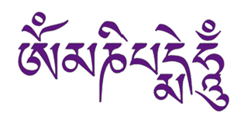
May the jewel

in the lotus

shine forth this light

of love

and compassion

to unite

all existences

as one
CLARITY YOGA SHALA

65 Hatfield Road

St Albans

AL1 4JE

ignite@clarity.yoga
www.clarity.yoga
+44 (0) 796 8823166

Clarity Yoga
Shala

YOGA TEACHER TRAINING
Pre Study Material : Asana Names

BACK BENDING SEQUENCE

Urdhva Dhanurasana
Urdva Upward Dhanu Bow

Paschimattanasana

CLOSING SEQUENCE

Inversions

Salamba Sarvngasana
All limb pose

Halasana
Plow

Karnapidasana
Kara Ear Padia Foot

Urdhva Padmasana
Urdhva Upward Lotus

Pindasana
Embryo

Mathsyasana
Fish Posture

Uttana Padasana
Uttana Extended Pada Foot

Sirsasana
Head

Baddha Padmasana
Baddha Bound Padama Lotus

Yogamudra
Yoga Mudra Seal

Padmasana
Lotus

Pranayam

Balance Breath

Utpluthih
Sprung Up
Ref: Michael Gannon of Ashtanga Americas; Astanga Yoga by Lino Miele

